

University of Engineering and Technology Peshawar,
Jalozai Campus

Name: MINAHIL
Registration No. 24JZELEO572

CEP Lab Report

Lab Report

Project Title
Energy Consumption and Solar PV Analysis using CityLearn Dataset

Objective
The objective of this lab is to analyze the electricity consumption of Building 2 using the CityLearn 2022 dataset, evaluate solar PV generation, calculate electricity cost with and without PV, and understand how solar energy reduces net consumption and cost.

Dataset Description
Two CSV files were used in this lab:
- Building_2 CSV file – contains electricity consumption and solar generation data.
- Price CSV file – contains electricity prices per hour.

Tools & Concepts Used
- Python
- Lists
- Loops
- Basic arithmetic operations
- Data visualization
- CSV file handling

Methodology

1. Loading the Data
- The building_2 CSV was loaded to extract energy consumption and solar generation.
- The price CSV was loaded to obtain hourly electricity prices.

2. Electricity Consumption
- The column “Equipment Electric Power [kWh]” was stored in a list named:
non_shiftable_load
- The net sum of this list was calculated to determine total electricity consumption.

3. Solar PV Generation
- The column “Solar Generation [W/kW]” was stored in a list.
- The values were converted into appropriate generation units.
- After multiplying by the installed PV system size, the result was stored in:
Net solar generation of building 2

4. Electricity Cost Without PV
- Electricity prices were stored in a list named:
price
- Hourly electricity consumption was multiplied by the price.
- The result was saved in:
- bill without PV
- The net sum of this list represents the total bill without solar energy.

5. Net Consumption with PV
- Solar generation was subtracted from electricity consumption.
- The result was stored in:
- Net consumption
- This list contained both:
  - Positive values → electricity drawn from grid
  - Negative values → surplus energy

6. Splitting the Data
- Positive values were stored in:
- Net electricity consumption with PV
- Negative values (surplus energy) were stored separately as wasted energy.
- Net sums of both lists were calculated.

7. Visualization
- Graphs were plotted to show:
  - Electricity consumption
  - Solar PV generation
  - Net consumption with PV
- These visualizations helped clearly understand energy savings and surplus production.
Code input:
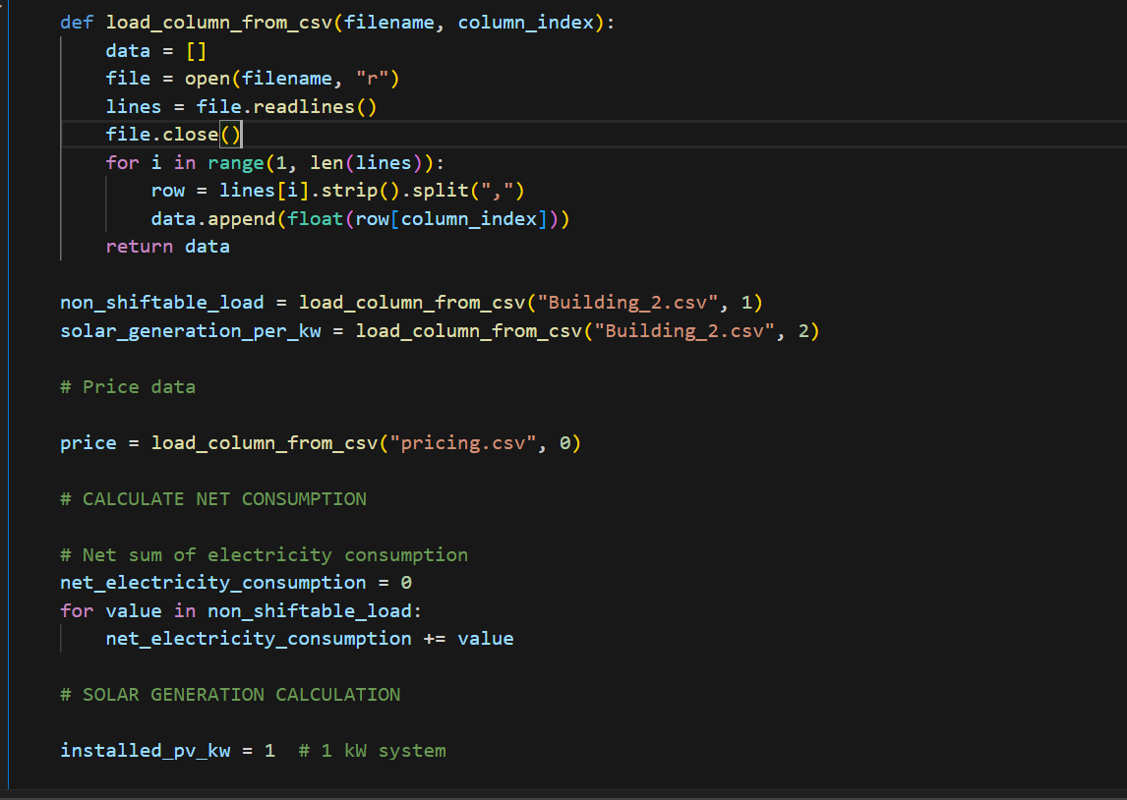
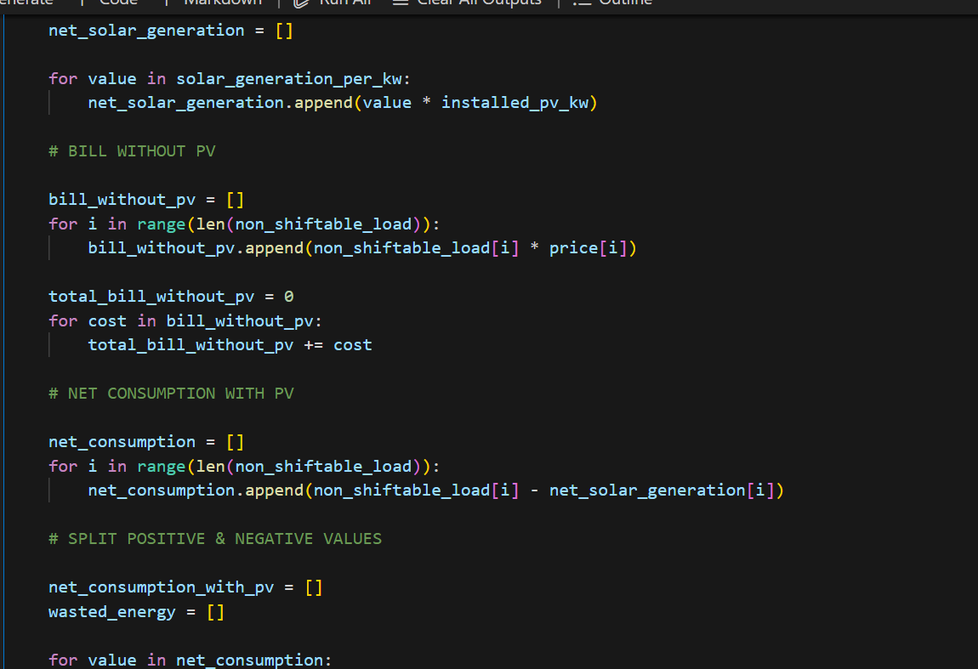

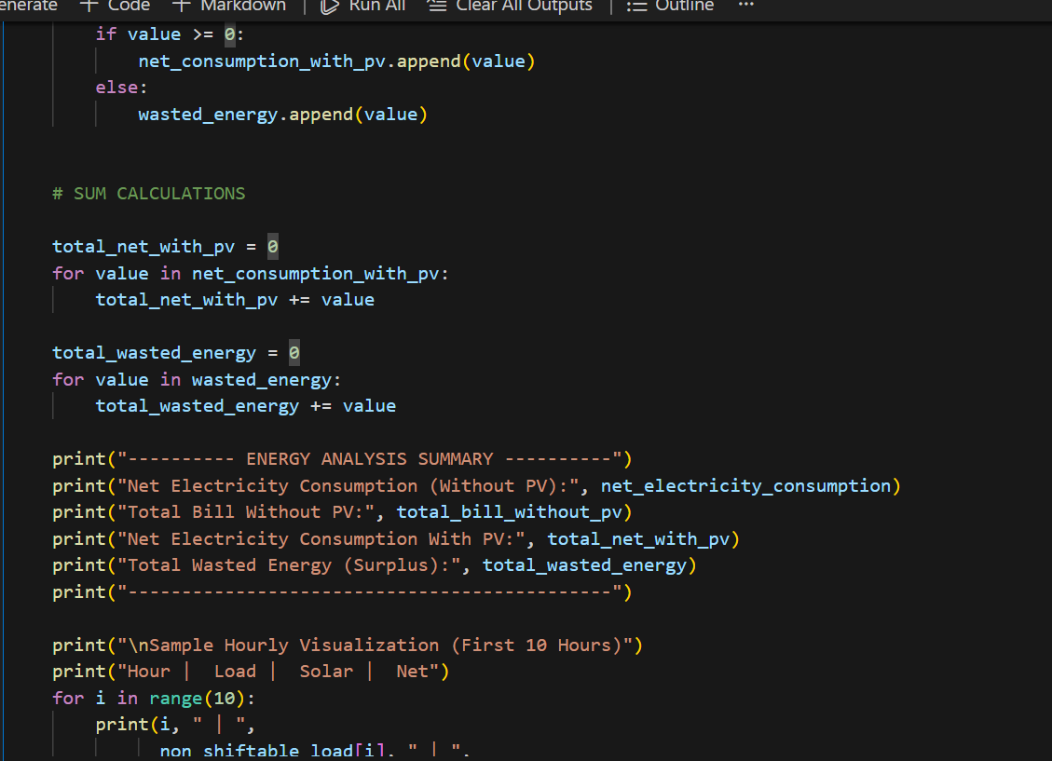

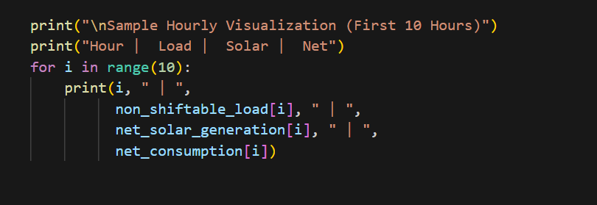

Code output:

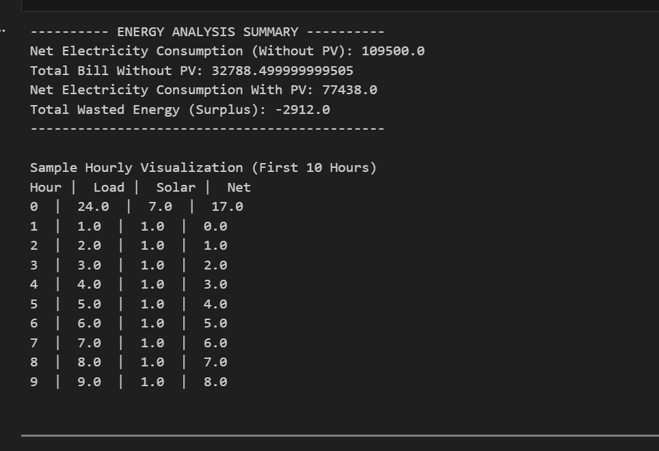

Observation
- Electricity consumption varies throughout the day and shows peak demand during certain hours.
- Solar PV generation is highest during daylight hours and reduces grid dependency.
- During peak solar generation hours, the net consumption becomes negative, indicating surplus energy.
- The electricity bill without PV is significantly higher compared to consumption with PV.
- Solar energy effectively reduces overall electricity cost and net power consumption.

Observation table

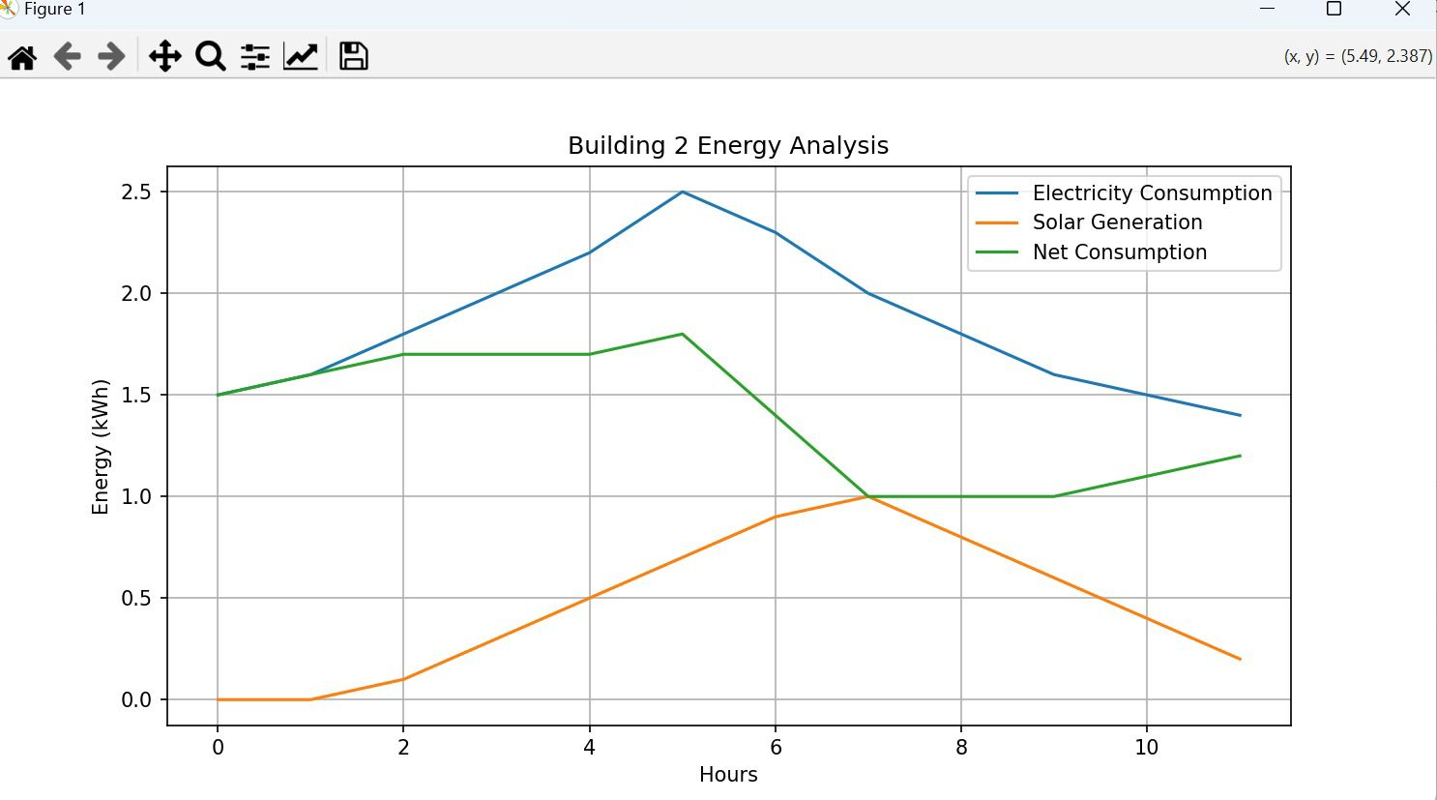

Results & Interpretation
- Solar PV significantly reduced net electricity consumption.
- During certain hours, solar generation exceeded demand, resulting in surplus energy.
- Electricity cost without PV was much higher compared to consumption with PV.
- Solar energy proves effective in reducing dependency on the grid and lowering costs.

Conclusion
This lab successfully demonstrated how solar PV systems can reduce electricity consumption and cost. By analyzing real-world data from the CityLearn dataset, we observed that renewable energy integration leads to energy efficiency and potential cost savings.

Remarks
- Code was structured and readable.
- All tasks were completed correctly.
- No runtime errors occurred.

